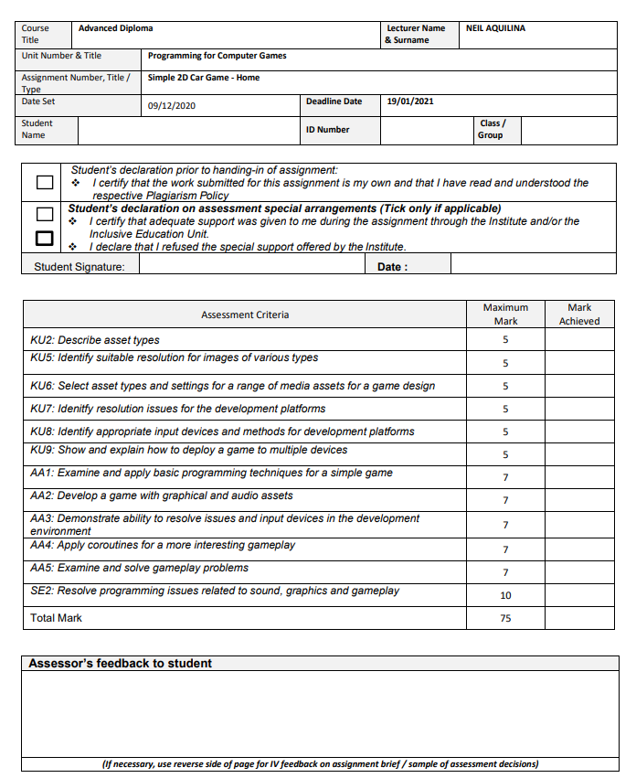

MSD-4.2A

361402L

Ayrton Ciangura

|  |  |
| --- | --- |
| Test Case 1 |  |
| Line Error | Invalid Expression term ‘;’ |
| Error explanation | A value was not put in. |
| Error correction | A value was put in |
| Error correction screenshot |  |

|  |  |
| --- | --- |
| Test Case 2 |  |
| Line Error | Invalid Expression term ‘;’ |
| Error explanation | A value was not put in well |
| Error correction | Had to be ++ instead of + |
| Error correction screenshot |  |

|  |  |
| --- | --- |
| Test Case 3 |  |
| Line Error | Name does not exist |
| Error explanation | Name EnemyMove did not exist in the script. |
| Error correction | Name was written badly |
| Error correction screenshot |  |

|  |  |
| --- | --- |
| Test Case 4 |  |
| Line Error | Text could not be found |
| Error explanation | Type or namespace could not be found |
| Error correction | Forgot to ad the unity ui |
| Error correction screenshot |  |

|  |  |
| --- | --- |
| Test Case 5 |  |
| Line Error | Generic method group requires 1 |
| Error explanation | Generic method was left empty |
| Error correction | GetComponent<Text>(); |
| Error correction screenshot |  |

|  |  |
| --- | --- |
| Test Case 6 |  |
| Line Error | Player does not contain a definition |
| Error explanation | Reference was not done well |
| Error correction | Player.GetHealth() |
| Error correction screenshot |  |

|  |  |
| --- | --- |
| Test Case 7 |  |
| Line Error | Method must have a return type |
| Error explanation | Method did not have a return type |
| Error correction | IEnumerator |
| Error correction screenshot |  |

|  |  |
| --- | --- |
| Test Case 8 |  |
| Line Error | Name does not exist in current context |
| Error explanation | Identity does not exist in current context |
| Error correction | Forgot Quaternion |
| Error correction screenshot |  |

|  |  |
| --- | --- |
| Test Case 9 |  |
| Line Error | Invalid token |
| Error explanation | ‘=’ is an invalid token |
| Error correction | int |
| Error correction screenshot |  |

|  |  |
| --- | --- |
| Test Case 10 |  |
| Line Error | Does not contain constructor that takes 3 arguments |
| Error explanation | A constructor that takes 2 arguments was added and not one that takes 3 |
| Error correction | Vector3 |
| Error correction screenshot |  |

|  |  |
| --- | --- |
| Test Case 11 |  |
| Line Error | No argument that corresponds to the required parameter. |
| Error explanation | ‘y’ was not added to vector2 |
| Error correction | Vector2(newXPos, newYPos); |
| Error correction screenshot |  |

|  |  |
| --- | --- |
| Test Case 12 |  |
| Line Error | Name does not exist in current context |
| Error explanation | SceneManager does not exist |
| Error correction | using UnityEngine.SceneManagement; |
| Error correction screenshot |  |

|  |  |
| --- | --- |
| Test Case 13 |  |
| Line Error | Method takes 0 arguments |
| Error explanation | LoadScene needs to take an argument |
| Error correction | LoadScene(0); |
| Error correction screenshot |  |

|  |  |
| --- | --- |
| Test Case 14 |  |
| Line Error | First argument type could not be found |
| Error explanation | No accessible extension method |
| Error correction | FindObjectsOfType<GameSession > ().Length; |
| Error correction screenshot |  |